### **Step 1. Create Table**

Create a table in your SQL database as follows

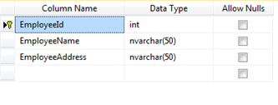

**Note:** EmployeeId is identity column.

### **Step 2. Create SSIS Project**

Click File >> New >> Project. Select Integration Services from the group. Specify some nice name. Say Ok.

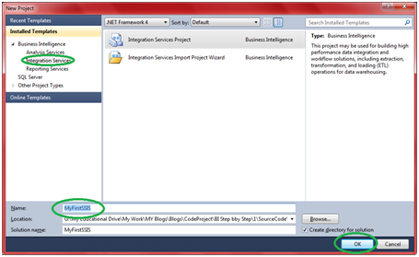

It will open up SSIS designer which you will use for creating and maintaining Integration service packages.

### **Step 3. Create Connection Manager**

3.1 Right click connection manager and say new ADO.NET connection.  
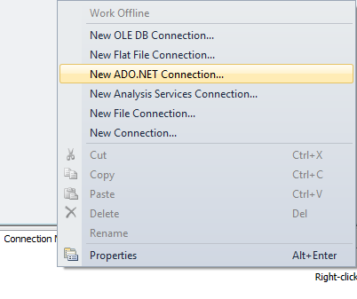

3.2 Click New  
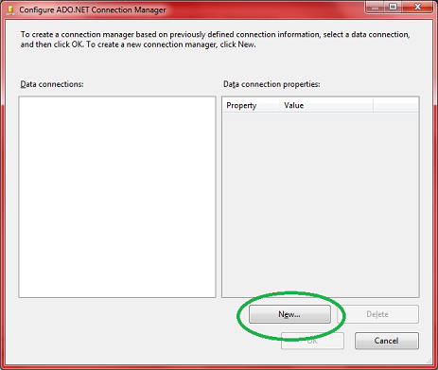

3.3 Enter Server Name, Enter Credential, and Select Database and click OK.  
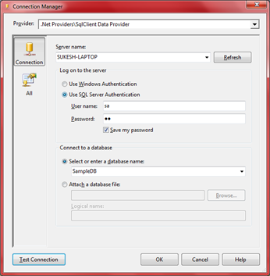

3.4 Click Ok again.

3.5 Rename connection manager to Lab2Connection.  
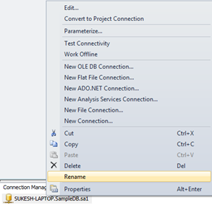

### **Step 4. Add Execute SQL Task**

In SSIS Designer by default control flow is selected. Take “Execute SQL Task” from the toolbox and add it in the designer.

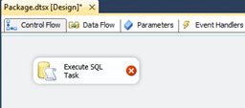

### **Step 5. Configure “Execute SQL Task”**

5.1 Double click the task, it will open up “Execute SQL Task Editor”  
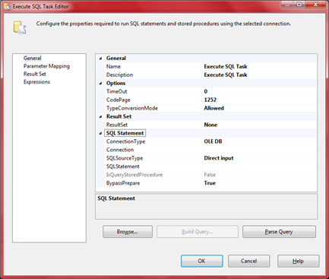

5.2 Make sure the left section General is selected. In the right section under SQL Statement group, change connection type to ADO.NET from default OLEDB.

5.3 Next set Connection property to one created in Step 3.

5.4 Next is SQLSourceType. It support three values,

5.4.1 File connection – Let us execute T-SQL Statement stored in a file.

5.4.2 Variable – Let us execute T-SQL statement stored in one of the variable.

5.4.3 Direct Input- let us provide T-SQL statement which we want to execute

**Note: On selecting one of the above value, a dynamic option will be displayed in the property window. For “Direct Input” a property called “SQL Statement”, For Variable a property called “Source Variable” and for File Connection property called “File connection” will be dispayed.**  
For our select “Direct Input”.

5.5 Click “Sql Statement”. A button with three dots in it will appear. Click it. It will popup “Enter SQL Query” dialog box. Enter query into it and click ok.  
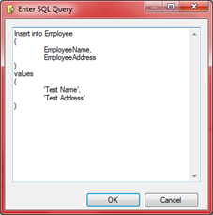

5.6 Click Ok in the “Execute SQL Task Editor” window.

### **Step 6. Execute Package**

Press F5 and execute the package.  
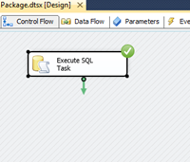

### **Step 7. Test the execution**

Open the sql server database and confirm record is inserted.  
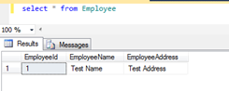  
**Note:** We are using hard coded query for demonstration. You can check the identity column and confirm whether actually values are inserted or not.